|  |  |  |  |  |  |  |  |  |  |  |  |  |  |  |  |  |  |  |  |  |  |  |  |
| --- | --- | --- | --- | --- | --- | --- | --- | --- | --- | --- | --- | --- | --- | --- | --- | --- | --- | --- | --- | --- | --- | --- | --- |
| |  | | --- | |  |  |  | | --- | | Photo of seats at an airport | | To get started right away, just tap any placeholder text (such as this) and start typing to replace it with your own. |  This would be a great place for a mission statement. You can use this fresh, professional brochure just as it is or easily customize it.  On the next page, we’ve added a few tips (like this one) to help you get started. To replace any tip text with your own, just tap it and begin typing. |  | |  |  |  | | --- | --- | --- | |  | Logo placeholder |  | |  |  |  | | Recipient  Street Address City, ST ZIP Code | Website  Email |  | | Company Name  Street Address City, ST ZIP | Tel Telephone  Fax Fax |  | |  | |  | | --- | | Company Name | |  | | Products and Services | | Logo placeholder | |

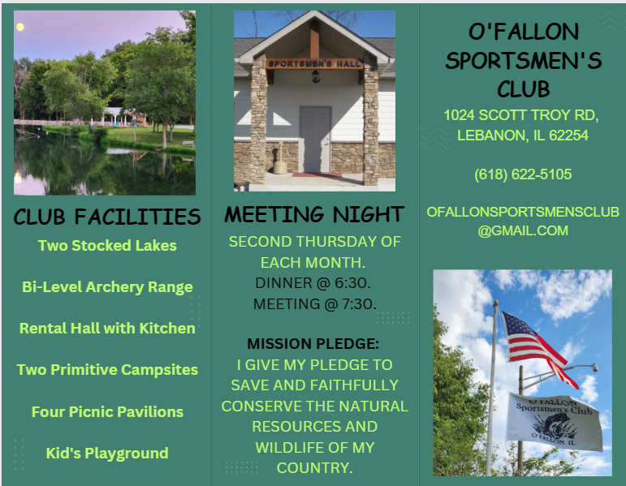

|  |  |  |  |  |
| --- | --- | --- | --- | --- |
|  |  |  |  |  |
| Think a document that looks this good has to be difficult to format? Think again!  * To easily apply any text formatting you see in this document with just a tap, on the Home tab of the ribbon, check out Styles. * Use styles to easily format your Word documents in no time. For example, this text uses the List Bullet style.  |  | | --- | | Photo of the outside windows on a building | | Find even more easy-to-use tools on the Insert tab, such as to add a hyperlink, insert a comment, or add automatic page numbering. | |  | |  |  |  | | --- | --- | --- | | View and edit this document in Word on your computer, tablet, or phone. You can edit text; easily insert content such as pictures, shapes, and tables; and seamlessly save the document to the cloud from Word on your Windows, Mac, Android, or iOS device. |  | Photo of silhouette of a person in front of a plane |  So what do you include in a brochure like this? We know you could go on for hours about how great your business is. (And we don’t blame you—you’re amazing!)  But since you need to keep it short and sweet here, maybe try a summary of competitive benefits at left and a brief success story here in the middle.  The right side of this page is perfect for those glowing testimonials and a list of key products or services. |  | Don’t be shy! Show them how fabulous you are. “Your company is the greatest. I can’t imagine anyone living without you.”  —Very smart customer  “This style is named Quote but you can also use it to call attention to an important piece of info.”  —Your friends in Word What you offer:  * Product or service * Product or service * Product or service * Product or service  Your most impressive clients:  * Big, important company * Another really well-known company |

